Welcome to the Doodle Grooming Guide!

Grooming is a key component, yet often overlooked aspect in taking care of your Doodle. Keeping a well-groomed dog is essential to maintaining their health, happiness, quality of life. This guide will instruct you on grooming as young as 8 weeks on into adulthood. In order for this to be the best experience for you and your Doodle, the most important thing to remember is: Be patient! Since we’re not all experienced with grooming, patience is necessary while doing each of these steps with your dog.

If it is frustrating for you at any time throughout the grooming process, take a break and come back later. We always want our Doodles to relate grooming with positivity!

PUPPY SECTION (8-14 weeks)
1. BATHING
Tools you’ll need:

- Mild soap
- Towel
- Washcloth

What to know: Avoid over-bathing or bathing too often for a puppy this young. It can be very irritating to the skin and can cause dry, red, or itchy skin.

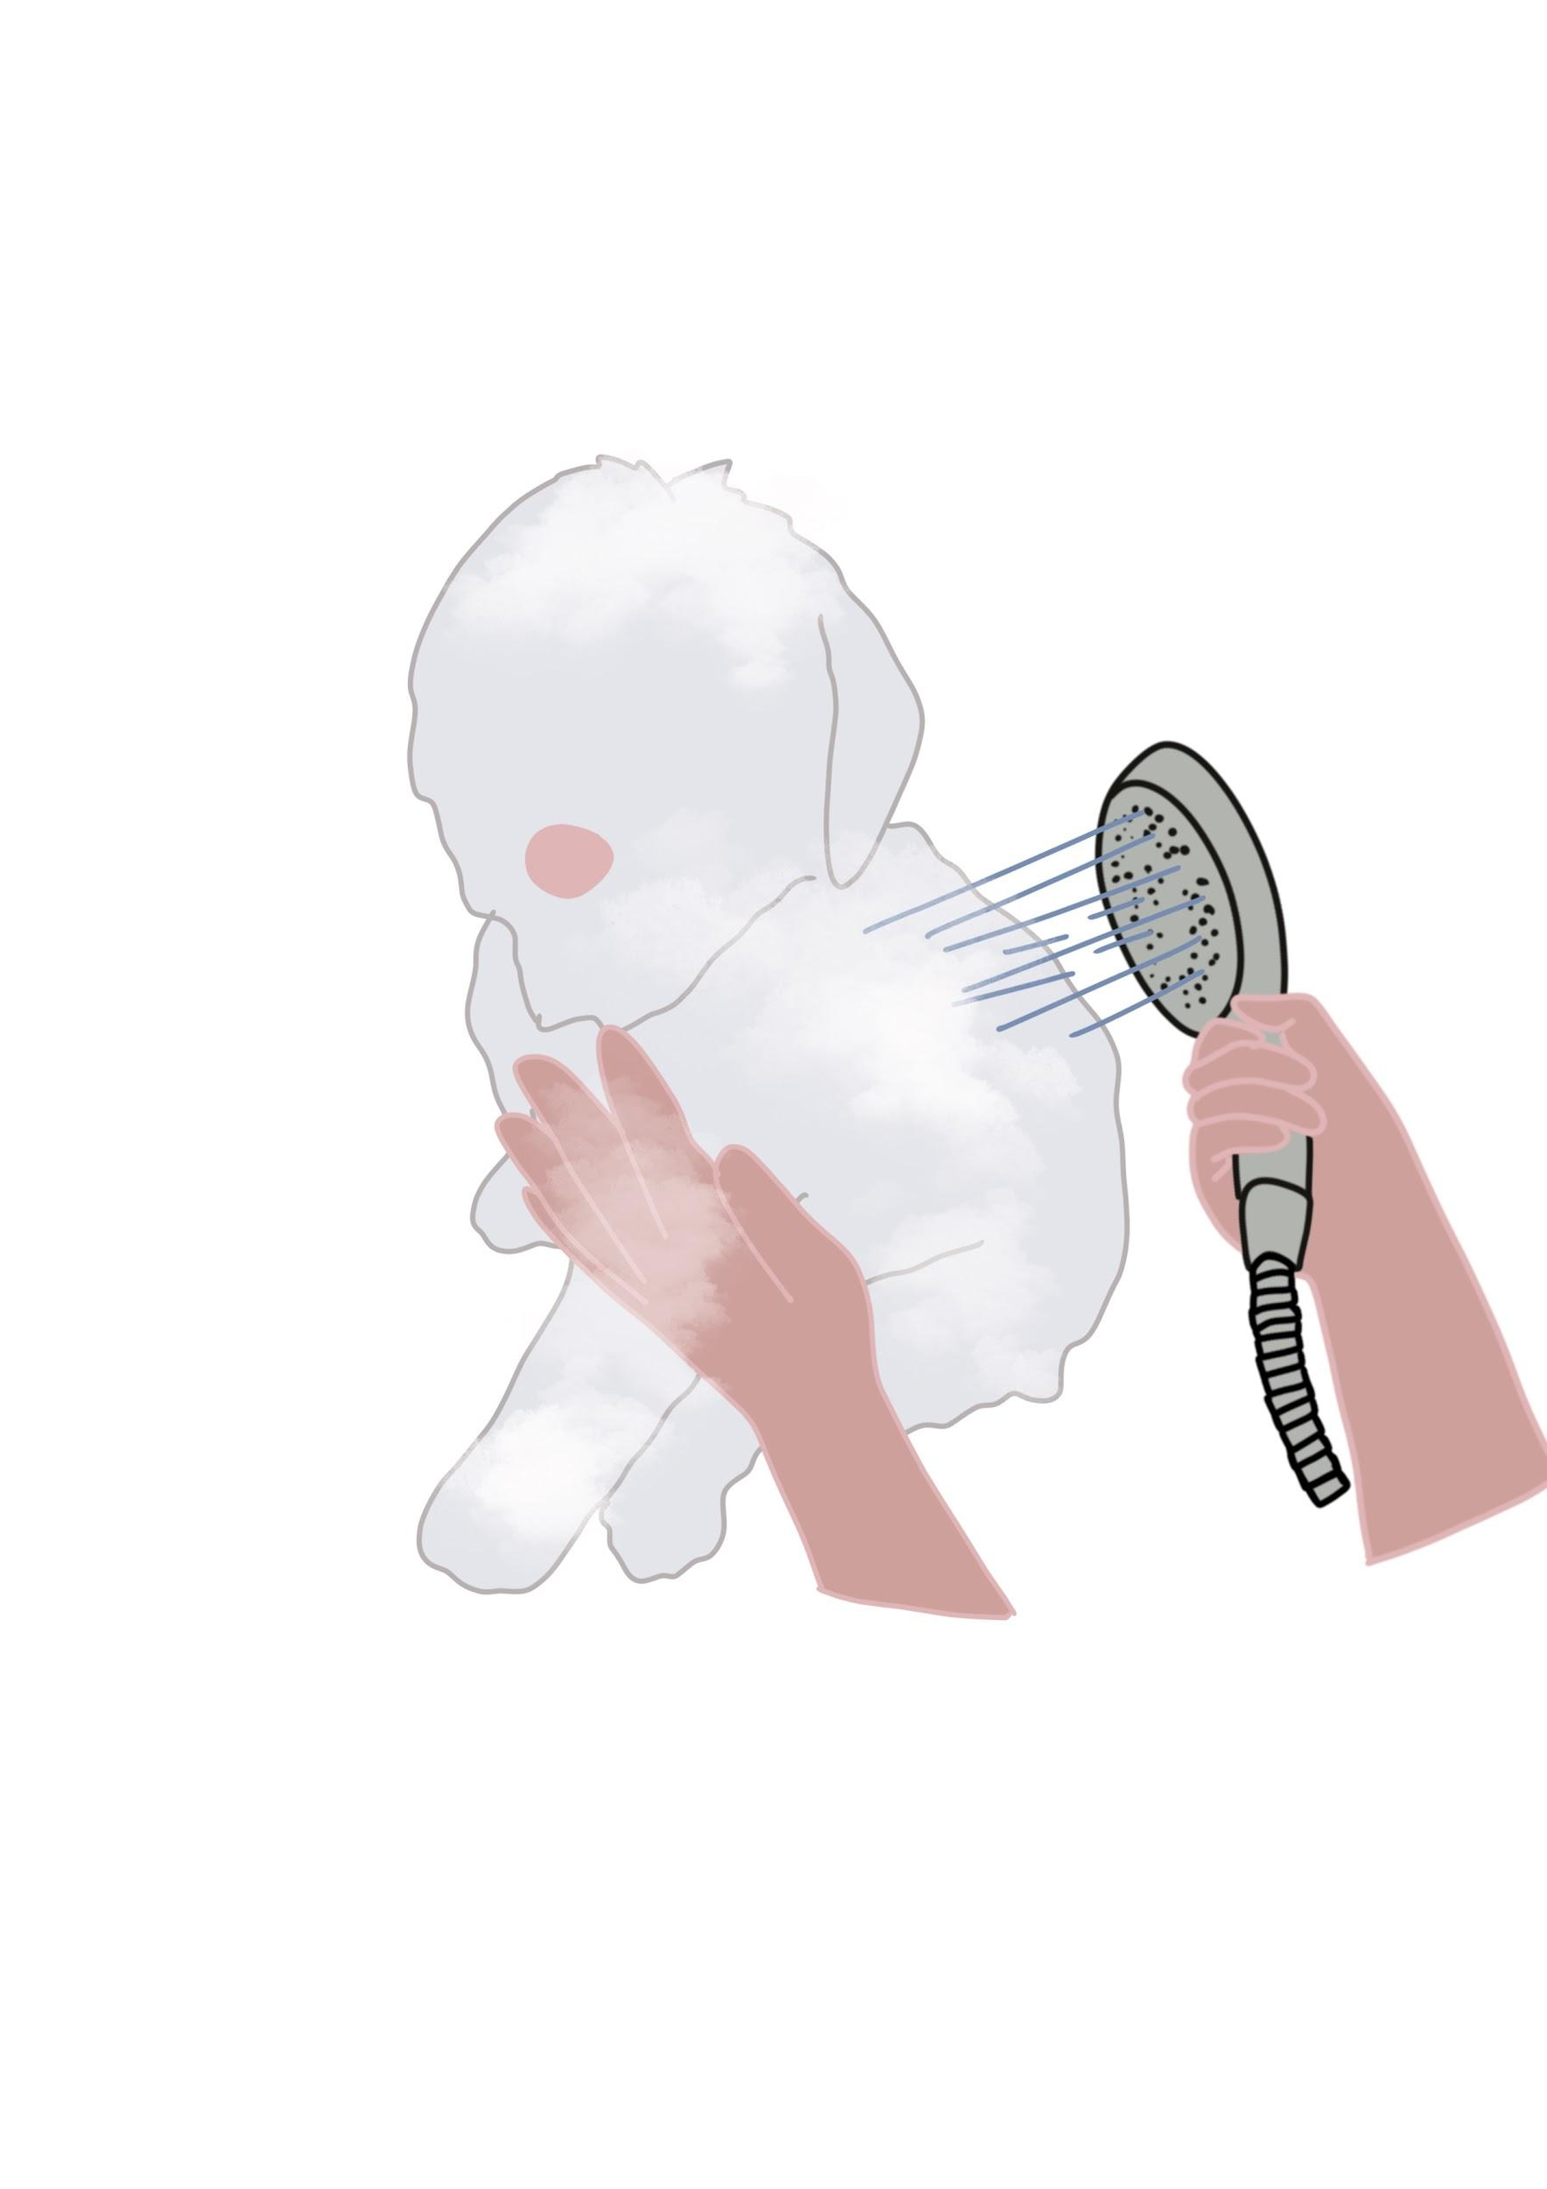
Instructions: Use mild soap on a washcloth. Make sure never to leave the soap in their coat. If you need to bathe them, we recommend warm - never hot water and using some very gentle soaps. Rinse well.

2. DRYING
What to know: After bathing, it’s important to not leave your puppy wet. Leaving them wet can cause low body temperatures, so it’s important to dry them completely. While drying them, avoid using high heat or a setting that is too cold. Always use the medium setting along with a low speed on whatever dryer you are using on your puppy.

Instructions: towel dry, then lightly dry your puppy with low speed and low heat. I advise not using the nozzle on your force dryer or instead using a hairdryer.
3. BRUSHING
Tools you’ll need:

- Gentle brush
- Puppy safe treats or lick mat
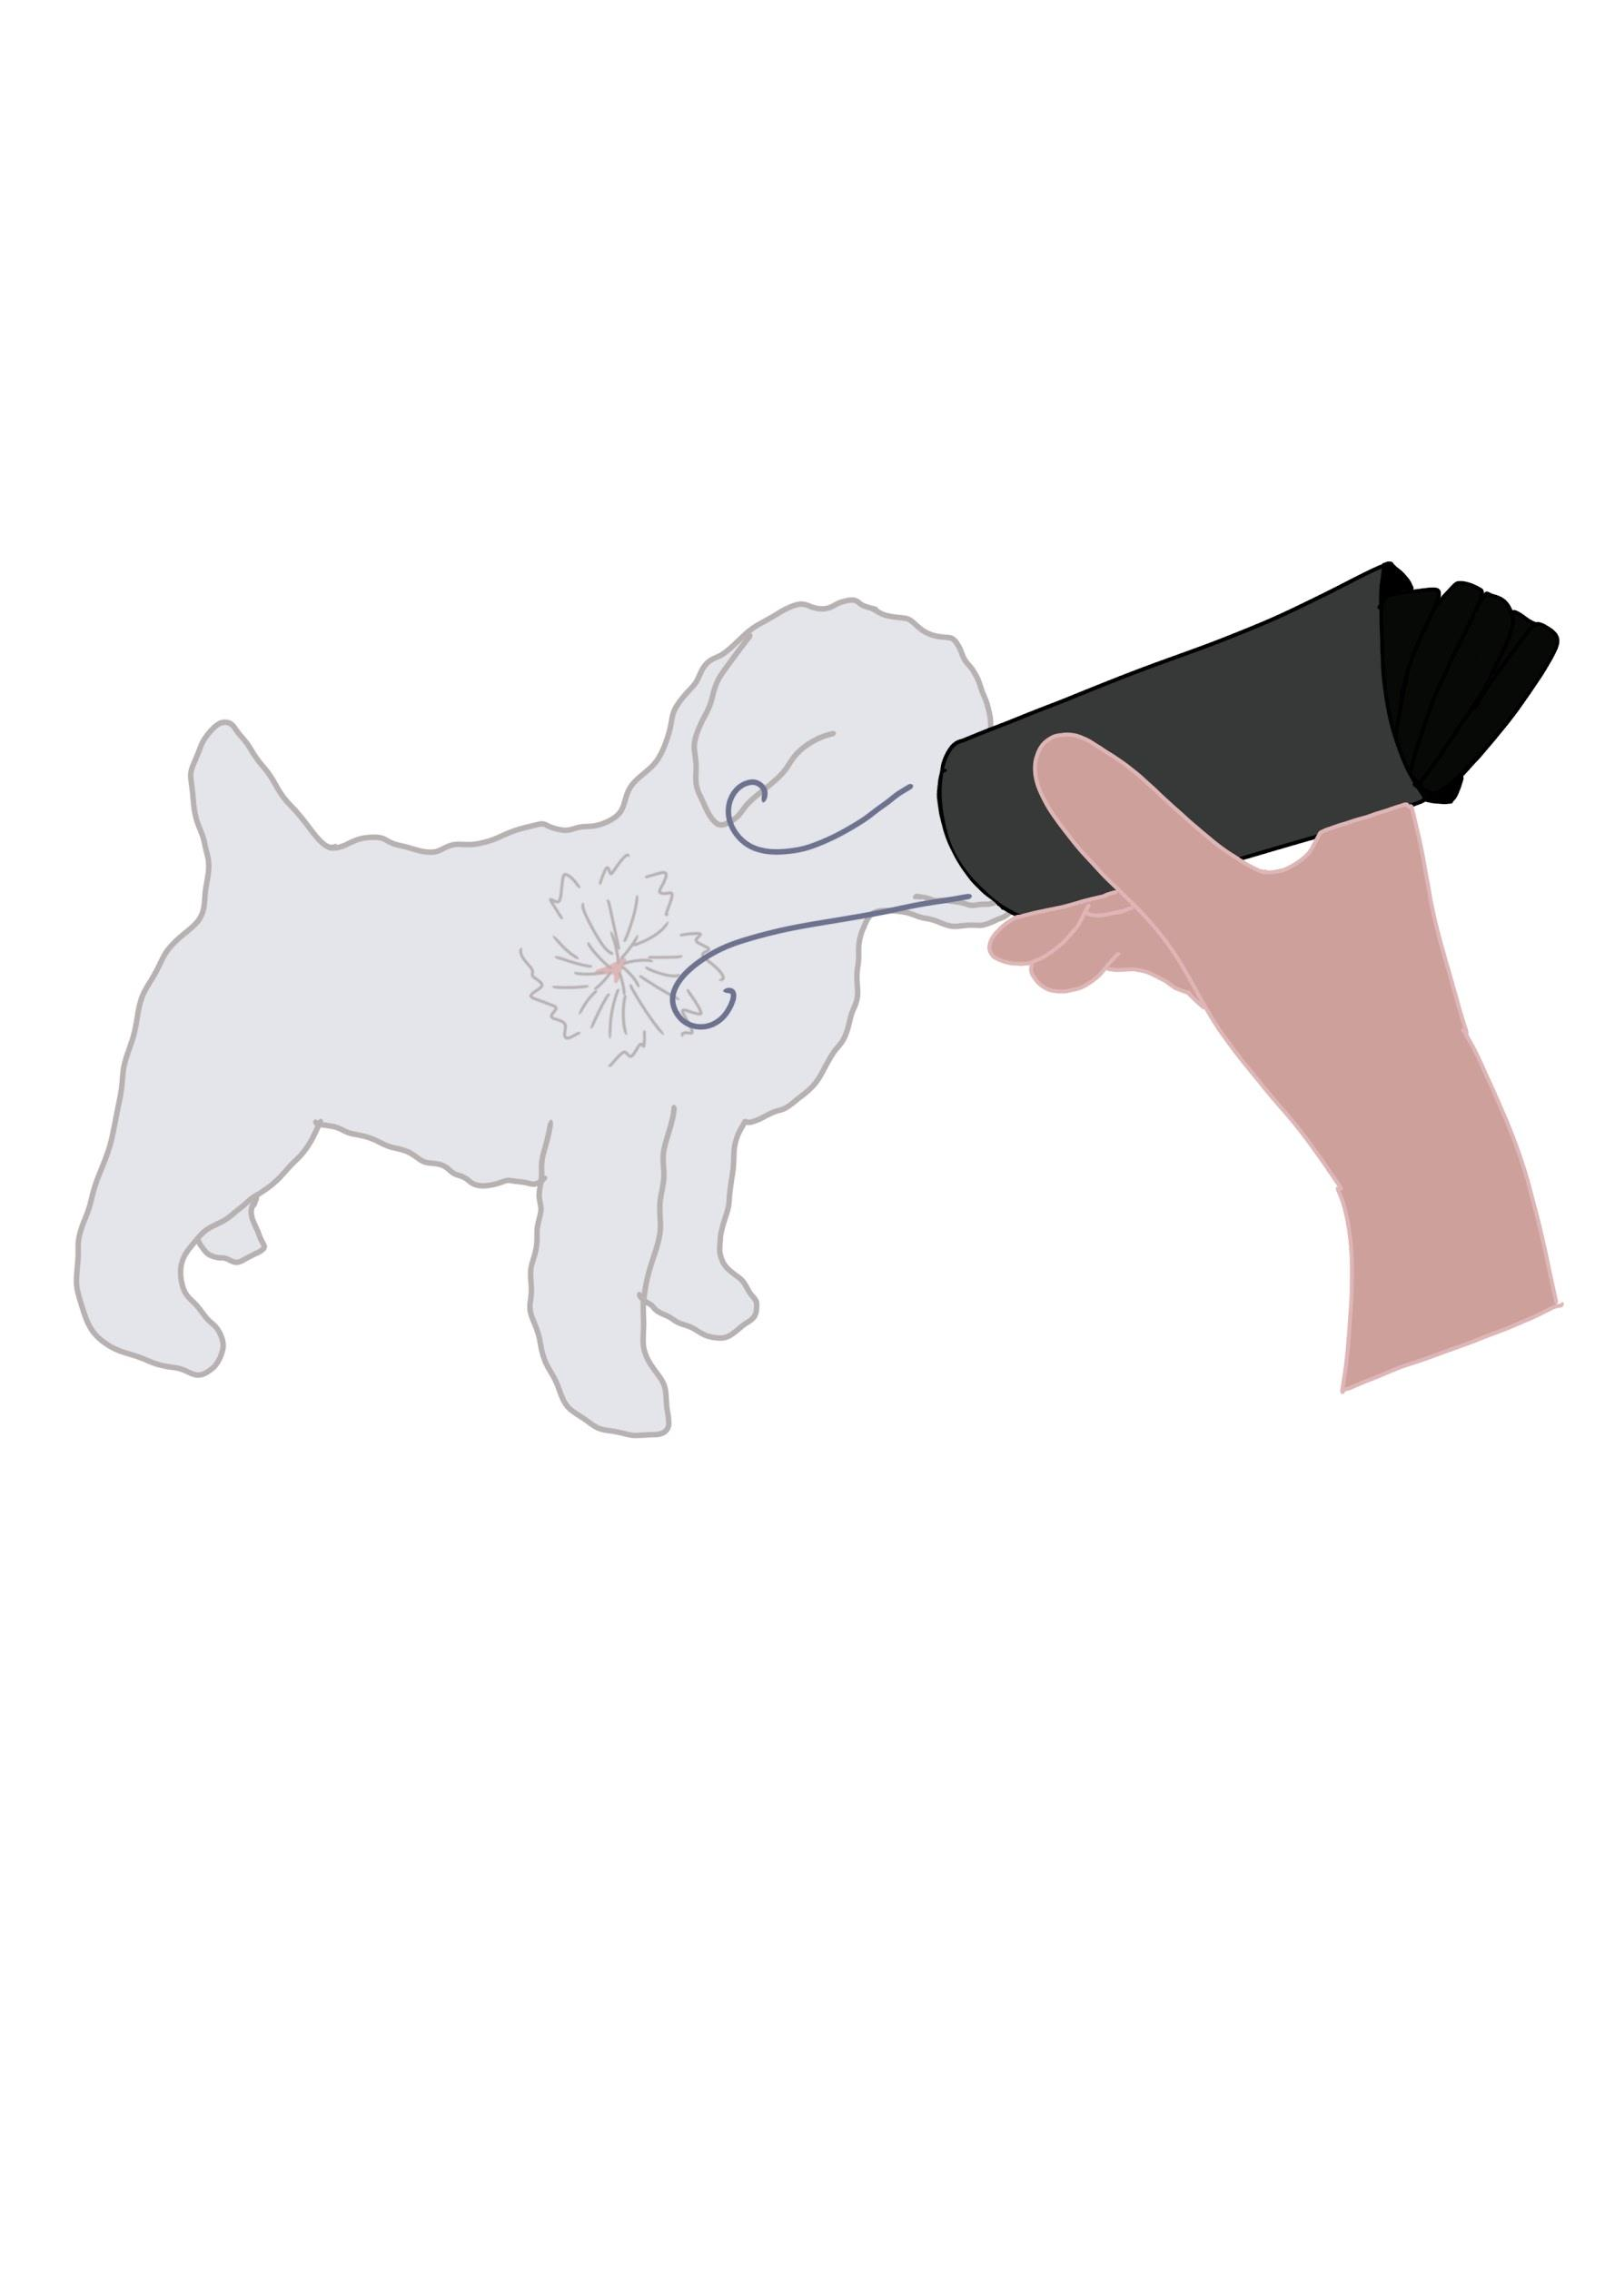
What to know: When a puppy is this young, it’s not so much about brushing out knots, because puppy hair does not require as much maintenance as an adult Doodle. Brushing a puppy is more about getting them used to and comfortable with the sensations itself.

Instructions:

When brushing your puppy, use the gentle brush. Make sure you are brushing all areas of your puppy’s coat.
Give lots of love and treats throughout the process.

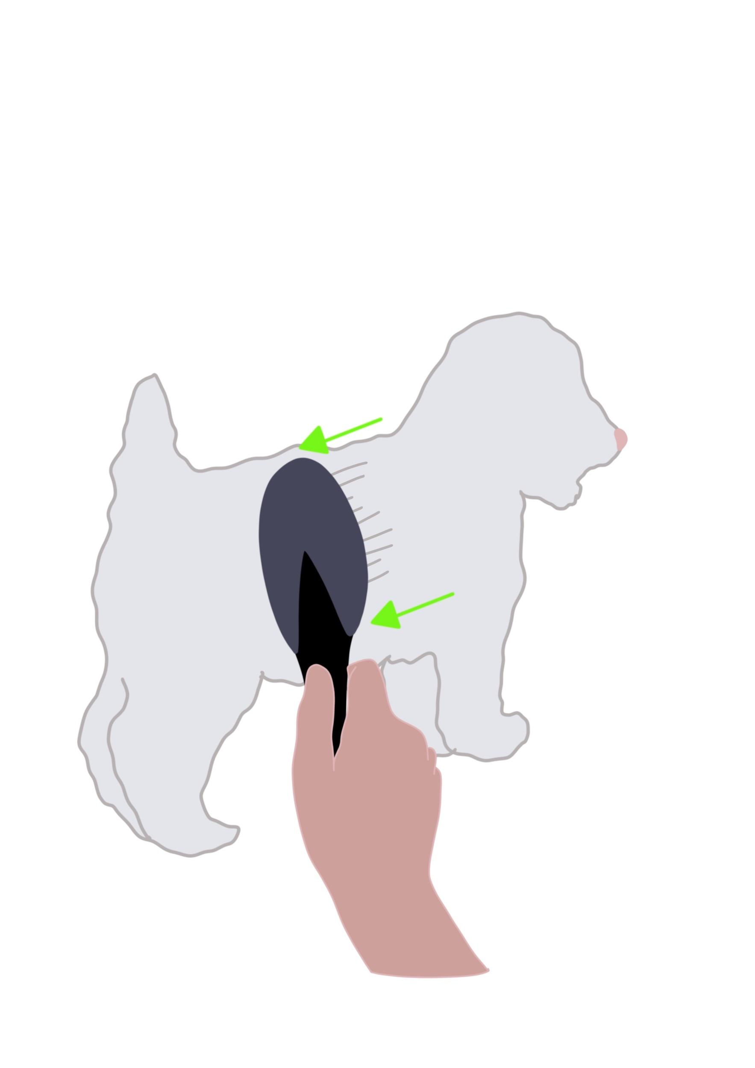
4. NAIL TRIMMING
Tools you’ll need:

- Fingernail file
- Puppy safe treats or lick mat

What to know: Nail trimming on young puppies is a must because it desensitizes them to their toenails being messed with and their nails are also needle-sharp at this age. Nail trimming will help cut down on unwanted scratching.

Instructions:

Use a regular fingernail file and lightly grind the tips of the nails. Give treats throughout this process to help create joy and happy feelings while getting their nails done.

Other grooming tips for your puppy:

- Incorporate the use of an electric toothbrush to rub the puppy down head to toe. This gets them used to the vibrations of the clippers and will prepare them for a future of regular grooming in adulthood.

We recommend taking your puppy to the groomer as soon as 9 weeks... or as soon as you feel comfortable!

It is important to call the groomer you have in mind to inform them of the breed you have. Let them know you are trying to get them used to a grooming salon environment. Talk to the groomer about bringing your puppy in for a brush and a sanitary trim/bath if necessary.

Make sure to ask these questions:

- Do you allow young puppies that don’t have all their shots yet?
- Do you know how to keep them safe? (Parvo, parasites, other common dog-related illnesses)
- Are you confident in handling a young puppy?
- Are you confident in the tools and soaps you have being used on a puppy this young?

It’s important to research your groomer in mind and read any reviews if possible. If you have any hesitancy or have a reason not to trust them, keep searching to find someone you do trust.

ADOLESCENT TO ADULT DOG

** IF YOUR DOG IS SEVERELY MATTED, DO NOT BATHE. PLEASE CONTACT A PROFESSIONAL GROOMER IMMEDIATELY **

The most critical areas to check most often for matting:

- Legs and armpit areas
- Outer thighs
- Neck/collar area
- Face/ears
- Tail
- Chest/underbelly

How do I tell if the coat is matted?

Part the hair and if you can’t see skin where the hair is parted, that is a sure sign of matting

1. BATHING
Tools you’ll need:

- Shampoo (Skouts Honor shampoo and conditioner in one recommended)
- Conditioner (optional)
- Towel

What to know: When soap is left in the hair, it can cause itching and irritation, which can lead to scratching extensively. This can cause unwanted matting. Using a conditioner can be great in aiding light knotting and itchy skin.

Instruction: Make sure your pup's hair is completely wet. After you shampoo all areas, rinse very well so that no soap is left in the coat. Follow up with conditioner and make sure to rinse well.

Areas where soap tends to hide and may need extra rinsing:

- Chin/under ears
- Underbelly
- Private area
2. DRYING
** IT IS IMPORTANT TO NEVER HAVE DRYERS ON HIGH HEAT **

Tools you need:

- Force dryer (recommended)
- Hairdryer
- Slicker brush
- Comb
- Happy Hoodie

What to know: It is critical to dry your Doodle completely after bathing in order to prevent matting. Anytime a Doodle coat is wet and air dries, you risk knotting and matting. You must expose your dog to drying regularly and often, especially at a young age. This ensures that they don’t develop an undesirable fear of the force dryers that are used at grooming salons.

Instruction: Towel dry, if you have a Happy Hoodie, place it over the dog's ears before you begin drying.
then carefully dry everywhere with force dryer, staying about 6 inches away from the skin. Avoid aiming air current directly in the face/nose area or inside ear canals.
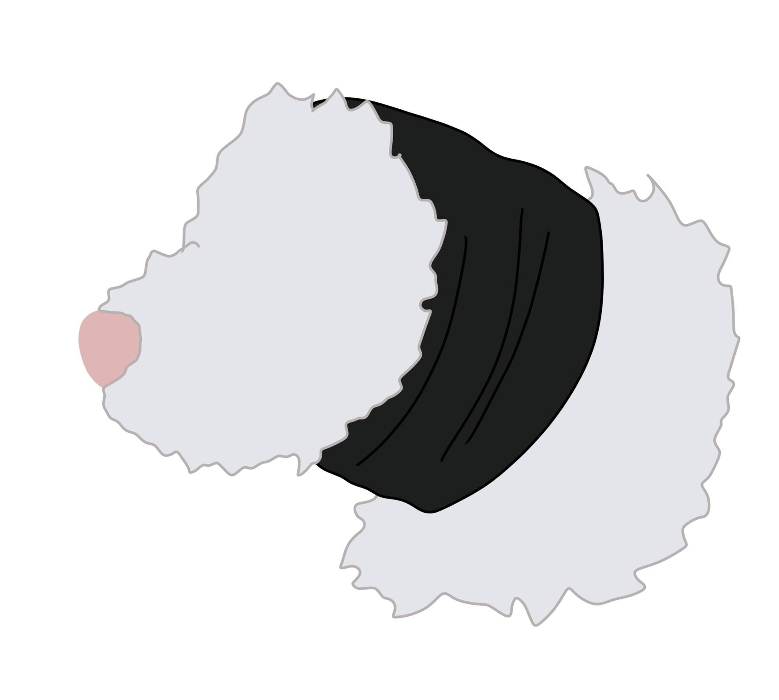
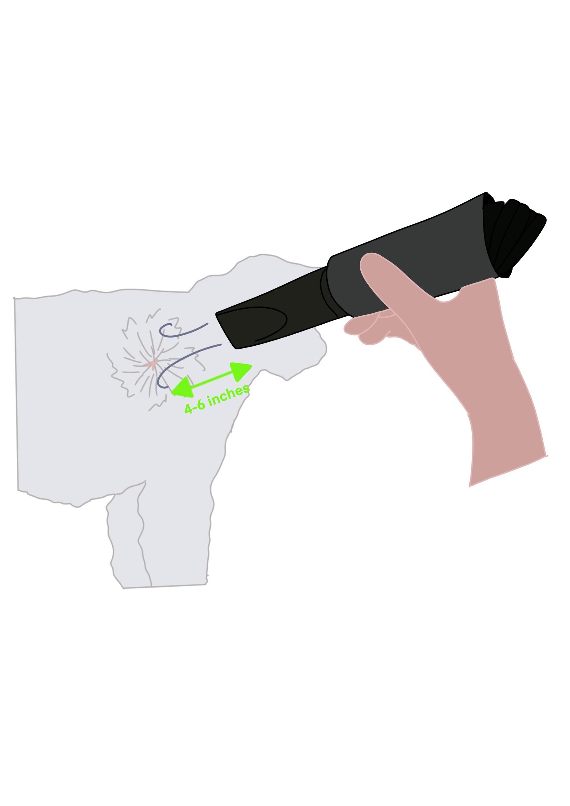

3. BRUSHING
Tools you’ll need:

- Slicker brush
- Metal comb

What to know: To avoid injuring your dog or causing brush burn, test out the different brushing angles on the soft part of your forearm before brushing your dog. If it hurts you, it will hurt them.

Instruction: When brushing a Doodle, you must brush down to the skin. A technique called “line brushing” is recommended. To line brush, you hold back the hair with one hand and brush down with the other. If they have any knots, you’ll want to go over it repeatedly (be very careful not to cause brush burn) until the knot is gone. Make sure to brush their entire body with this tool before the next step.

Next, you’ll want to use your metal tooth comb. The goal is for the comb to run through the hair smoothly. Compare it to cutting through partially melted butter with a hot knife. If the comb gets hung up, then refer back to the previous tool and instructions for that area until the knot is gone. When the comb runs through smoothly, your job is done.
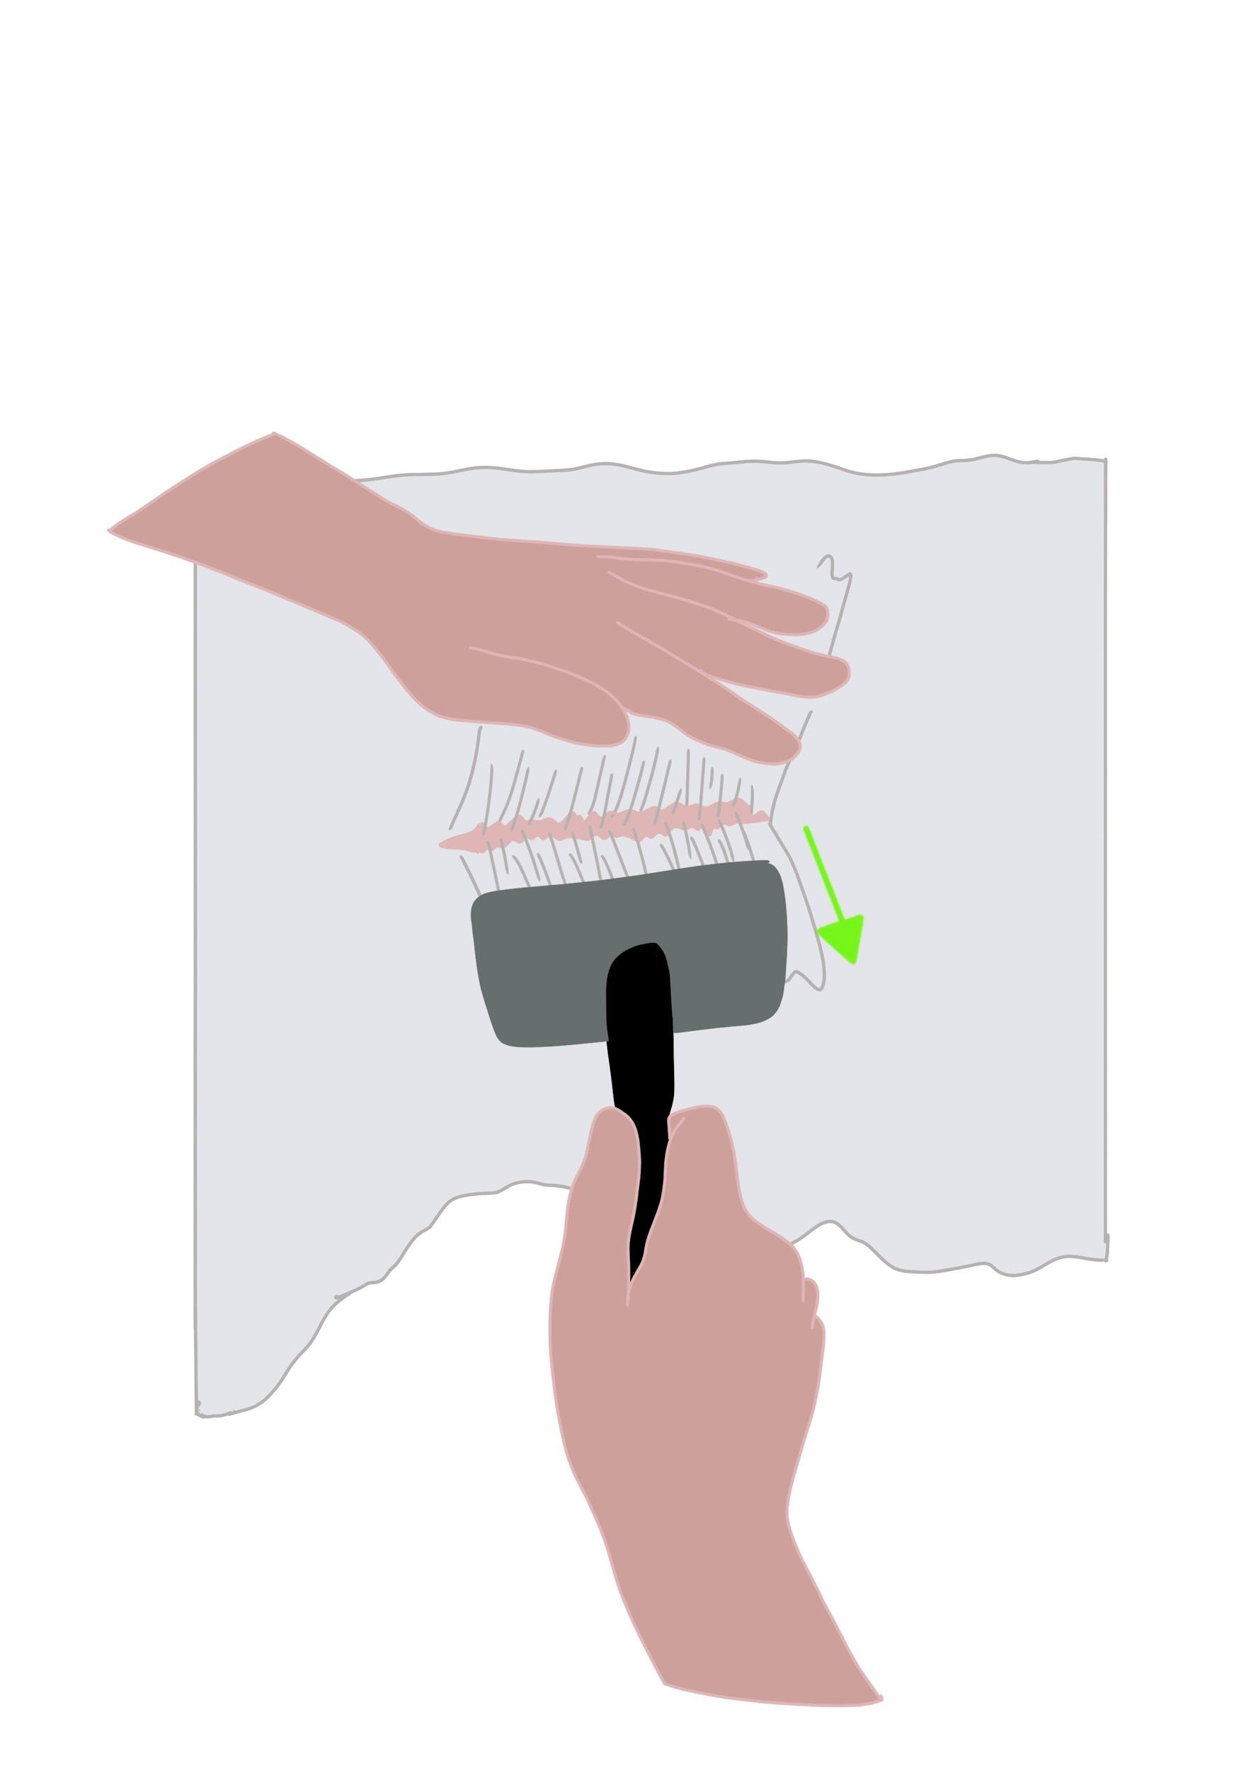

4. EAR CLEANING
Tools you’ll need:

- Grooming ear powder
- Ear cleaner
- Cotton pads

What to know: Some Doodles can grow excessive hair in their ear canals and it’s important to keep this clear. This will prevent infections and bad odors. You can either remove the hair yourself or regularly take your dog to the groomer or vet to have them do it.

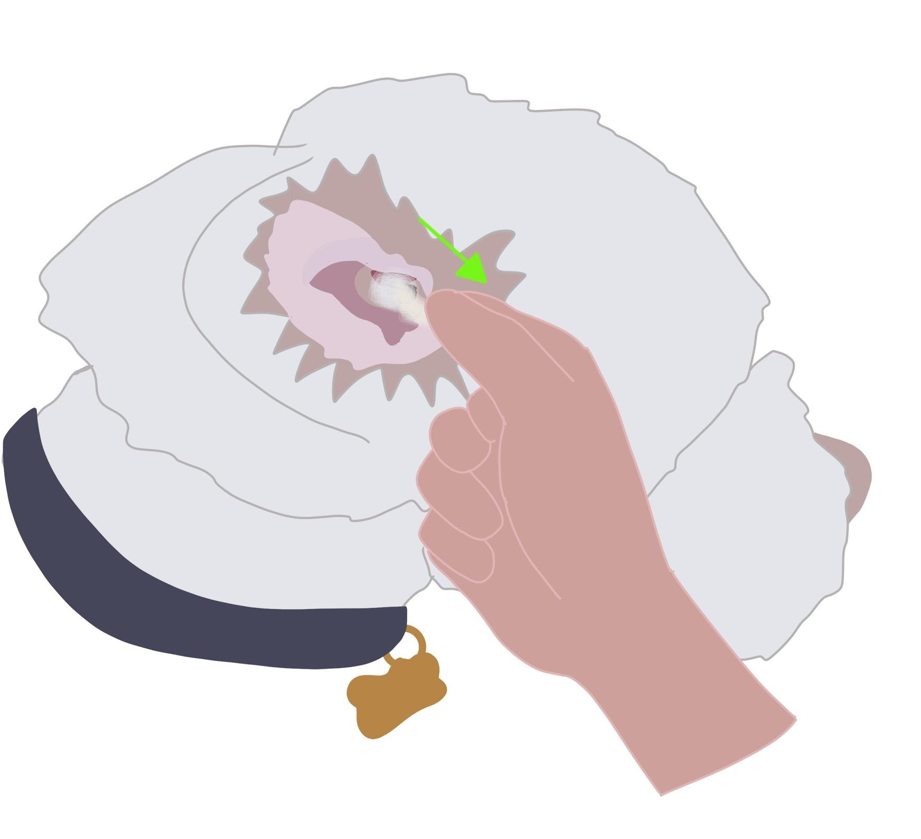
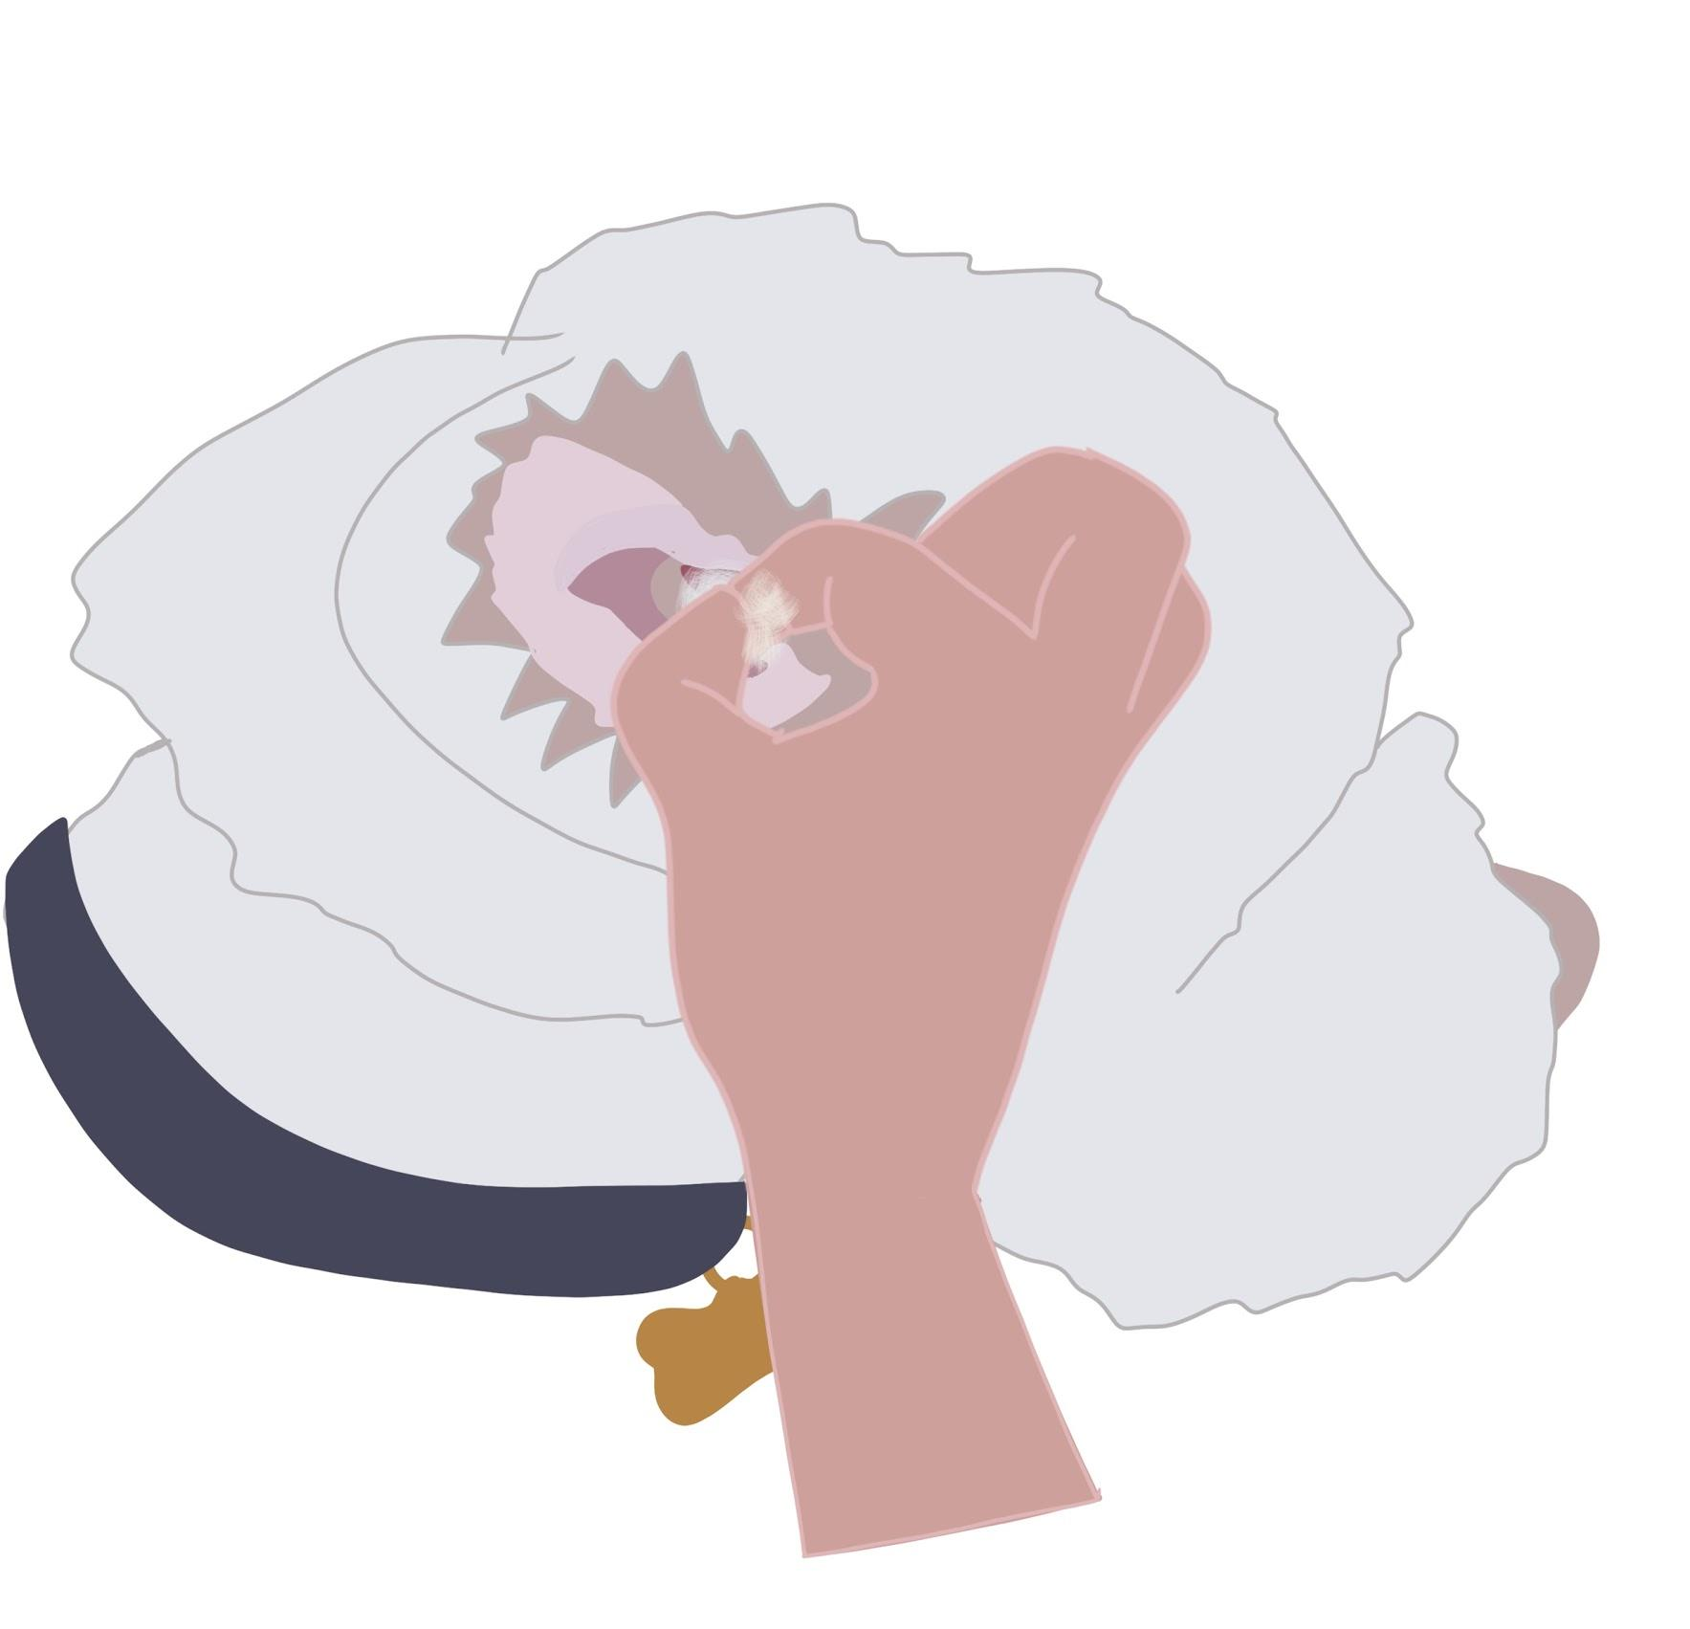
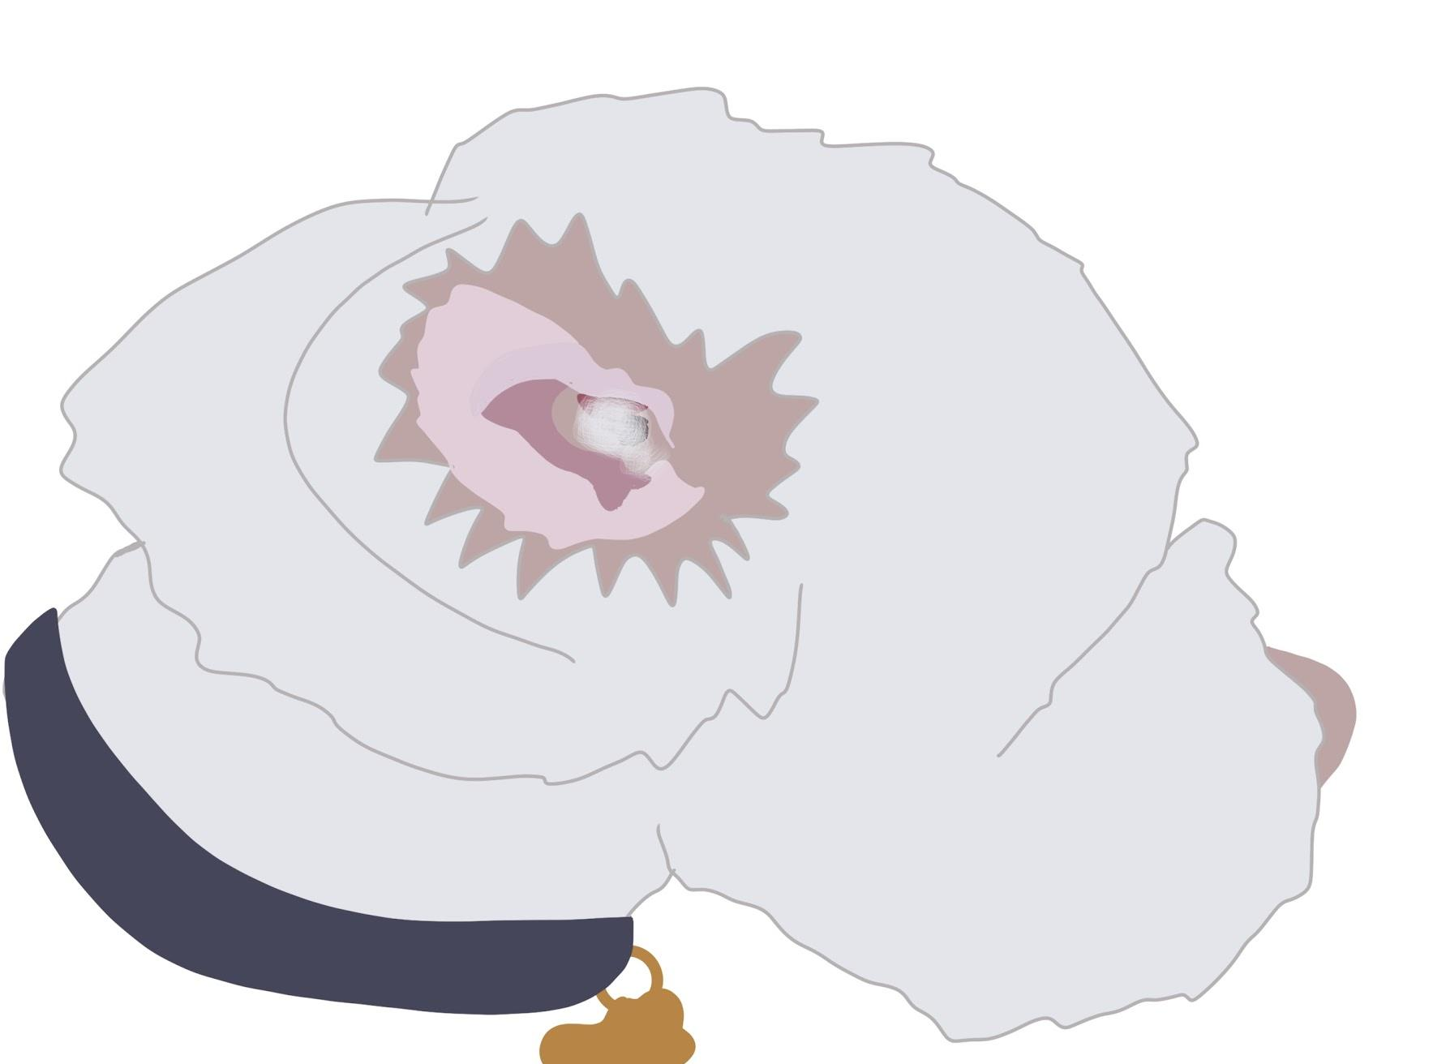
Instruction: Fold the ear back so that you can see inside the ear canal. Use the ear powder first by coating the hair inside the ears, then pinch the hair with your pointer finger and thumb and pull. This can be a very difficult process and if you are struggling, please contact a professional. After removing hair completely from the ear canal, use a cotton pad, and cover it in ear cleaner, wiping out the inside of the ear.

5. NAIL TRIMMING
Tools you’ll need:

- Nail clippers
- File

What to know: It is not recommended to try this step yourself on your adult dog, unless you have been trained to do so or have guidance from a professional. This can be a very dangerous and unpleasant experience for you and your pet. Please proceed with caution.

Instruction: When using nail clippers to trim your dog’s nails, you have to be very careful to stay clear of the quick inside the nail. If you accidentally clip this part of the nail, it can cause severe bleeding. Make sure to look over the guide to help you in positioning the clippers. Once clipped, take the file and smooth the edges of the nails. Nails are known to become sharp and jagged after trimming. The red line in the diagram indicates a small hump underneath some dog’s nails - this is where the tip of the quick ends. Make sure to hold as much hair back as possible with your thumb so that you have a good view of the nail. It is helpful to secure the nail you are clipping between your pointer finger and thumb.

** In case of toenail emergency **

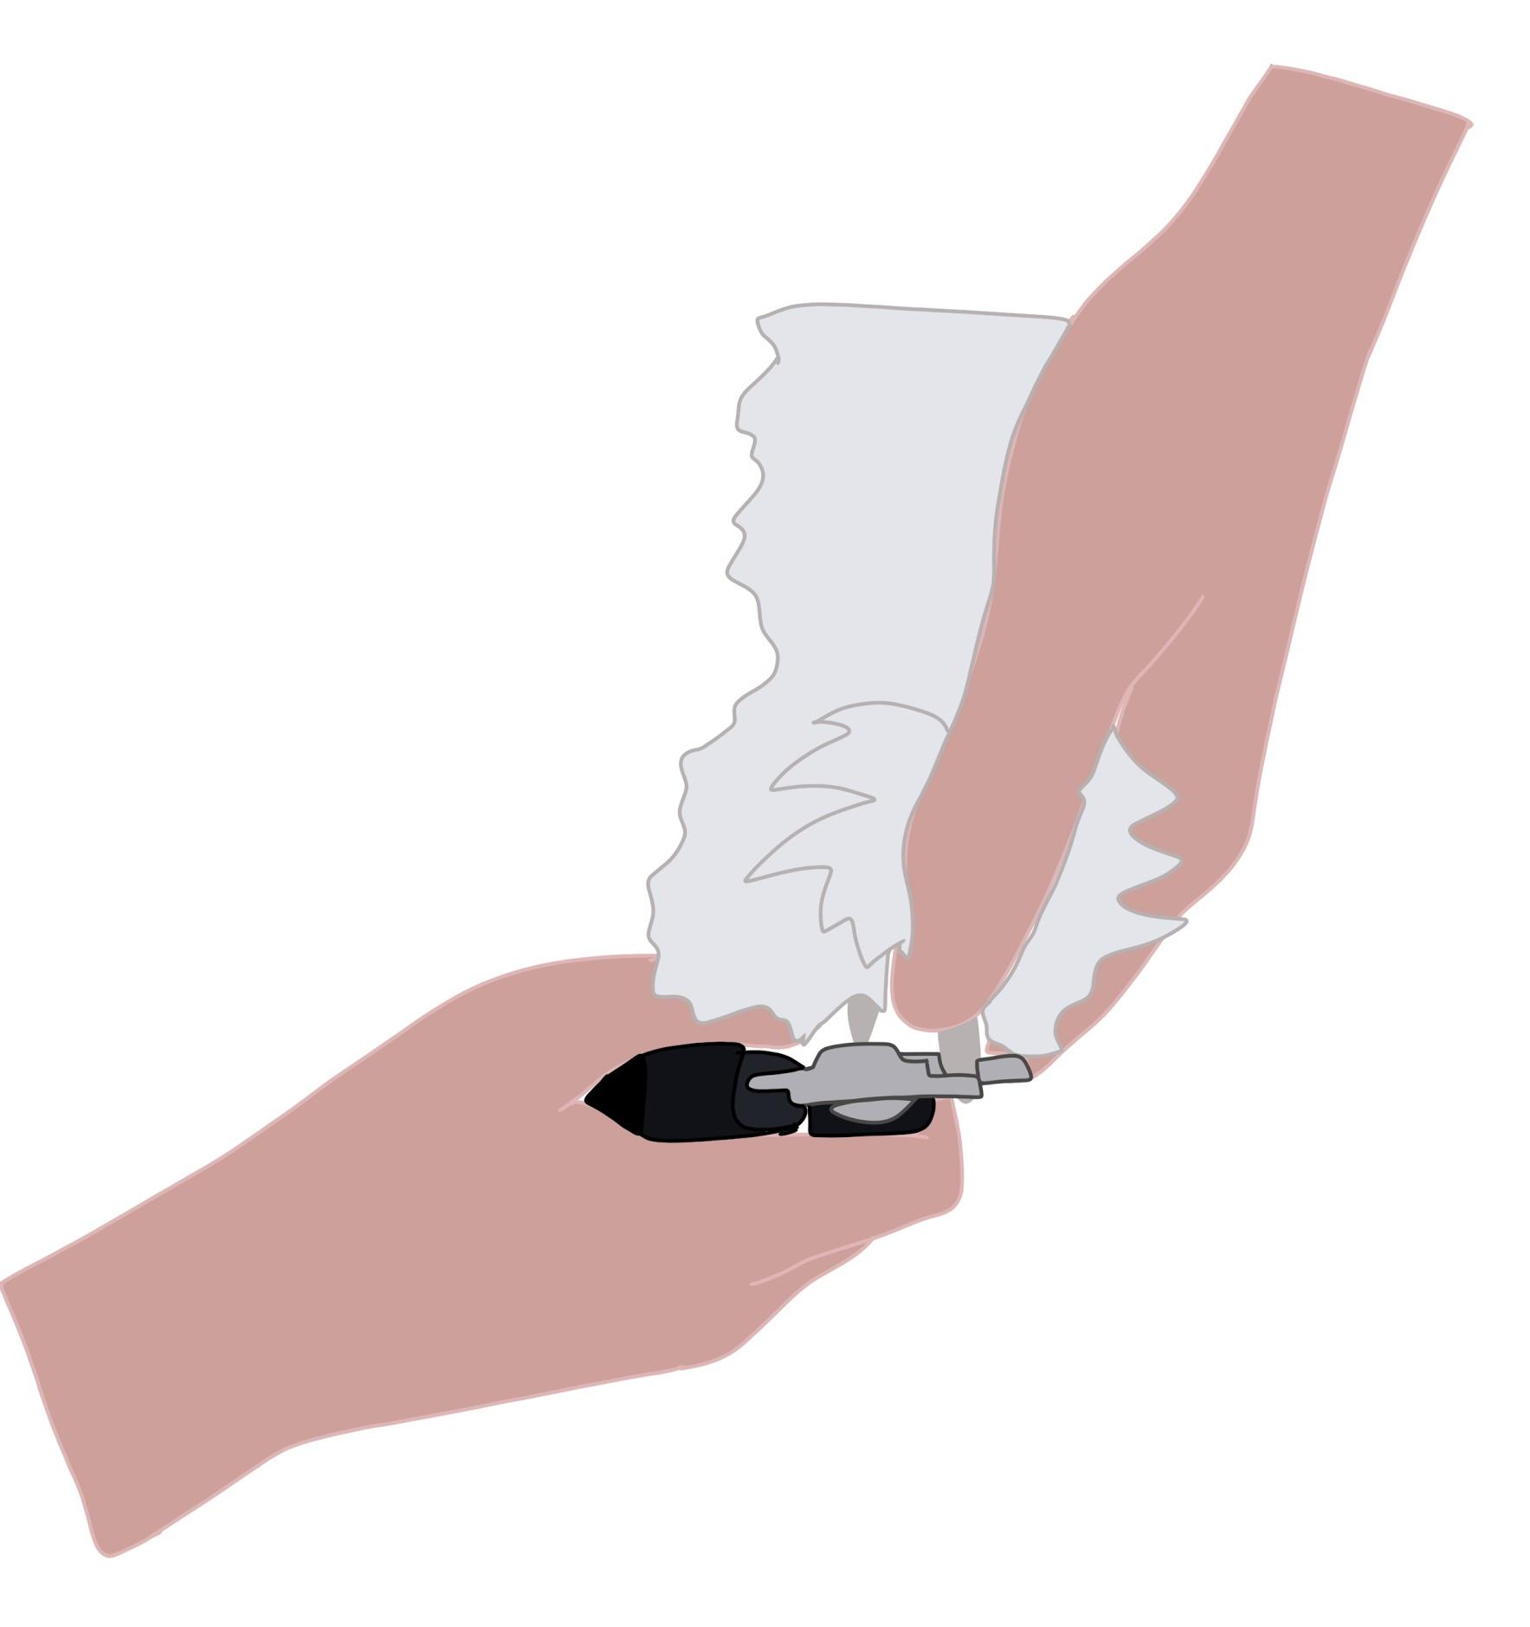
Styptic powder - this will stop bleeding in case you clip the quick. Use this by sticking the dog’s toenail into the powder, or rubbing powder on the nail with your finger. If you don’t have styptic powder on hand, regular household flour can also stop bleeding.

